Heart disease detection: methods and applications

October 2, 2016

INvoice #1234

|  |  |
| --- | --- |
| Bill To | Ship To |
| |  |  | | --- | --- | | Customer | [Customer Name] [Company] | | Customer ID# | [Customer ID] | | Address | [Address] [City, ST ZIP Code] | | Phone | [Telephone] | | |  |  | | --- | --- | | Recipient | [Recipient Name] [Company] | | Address | [Address] [City, ST ZIP Code] | | Phone | [Telephone] | |
| |  |  | | --- | --- | | Payment Due | [Select Date] | | Salesperson | [Salesperson Name] | | Payment Terms | [Terms] | | |  |  | | --- | --- | | Delivery Date | [Select Date] | | Shipping Method | [Ship Method] | | Shipping Terms | [Terms] | |

| Art. | Tech | Features | Description | Disease | Accuracy | Note |
| --- | --- | --- | --- | --- | --- | --- |
| 1 | Spectral turbulence analysis of SAECG | Mean peaks per slice (MPPS); low-segment correlation ratio (LSCR); intersegment correlation mean (ISCM); intersegment correlation standard deviation (ISCSD); and spectral entropy (SE).  The spectral turbulence analysis was considered abnormal when at least 3 of the 4 indices were abnormal: LSCR > 73; ISCM < 92; ISCSD > 105; and SE > 14. | Averaged X-Y-Z lead on the segment starting 25ms before the QRS onset and ending 125ms after the QRS offset. This segment was divided into overlapping 24ms slices in 2ms steps. Each time slice was multiplied by a 4-pole Blackman-Harris window and analyzed using the fast Fourier transformation. In order to detect the abrupt changes in activation wave-front velocity caused by abnormal myocardial regions  Computing the positive predictive characteristics (PPCs), that is, curves expressing the dependence of positive predictive accuracy (i.e., the ratio [true positive]/[true positive + false positive]) on sensitivity for these 5 features | ischemic ventricular tachycardia, arrhythmic events,  sudden arrhythmic death,  cardiac death | ***See figure 1.1, 1.2***  Optimal criteria for risk stratification after myocardial infarction. These criteria are as follow: MPPS > 36; LSCR > 68; ISCM < 90; ISCSD > 136; and SE > 13, with the strategy requiring at least three indices to be positive for a positive diagnosis | orthogonal X,Y,Z leads using a Model 1200 EPX Arrhythmia Research Technology (Austin, TX, USA) recorder |
| Time series analysis of SAECG | Three conventional time domain indices were calculated: the duration of the total QRS complex (tQRS); the duration of the terminal low-amplitude signals < 40*fj, Y* (LAS40); and the root mean square voltage of the last 40ms of the QRS complex (RMS40)  Considered abnormal when at least 2 of 3 variables were out of rangers: tQRS > 114ms; LAS40 > 38ms and RMS40 < 20*fiW* | Computing the positive predictive characteristics (PPCs), that is, curves expressing the dependence of positive predictive accuracy (i.e., the ratio [true positive]/[true positive + false positive]) on sensitivity for these 3 features | ischemic ventricular tachycardia, arrhythmic events,  sudden arrhythmic death,  cardiac death | ***See figure 1.1, 1.2***  Spectral turbulence analysis of the SAECG was a better predictor of **cardiac death** than time-domain analysis. However, the two methods were equivalent for the prediction of ventricular tachycardia, sudden arrhythmic death, and arrhythmic events |  |
| 3 | Logistic regression of SAECG, Holter, Radionuclide Ventriculography | SAECG: magnitude of voltage signal in the last 40ms of the filtered QRS, duration of QRS  Holter: Lown Grade system  Radionuclide Ventriculography used to assess ventricular ejection fraction | SAECG: a low voltage signal in the last 40ms (<40uV) of the filtered QRS complex, a long filtered QRS complex (>120ms)  Lown Grade of Holter: Complex ventricular ectopic (3-5), frequent ventricular (>10), Non-sustained ventricular tachycardia (>3 + fast HR: 120/min)  Ventriculography: ventricular ejection fraction <40%  More information, see **table 2, figure 3.1** | ventricular tachycardia,  left ventricular dysfunction,  complex ventricular ectopic  activity | An equation is generated that allows assessment of risk :  The finding of an abnormal SAECG in the presence of an ejection fraction <40% identified patients with a 34% probability of arrhythmic events, associated with a sensitivity of 80% and a specificity of 89% | Data analysis was performed using Student's t test, and the chi- square method  210 patients |
| 2 | Correlation-analysis of the clustered ECG waveforms | QRS detection algorithm, RR intervals clustering technique, T-wave and P-wave detection algorithm | The compete detection of T-wave and Q-wave:  1. QRS detection algorithm (noise robust) to create RR intervals  2. Clusters of RR intervals are created with the time-requirement (t < threshold) and geometry-requirement (mean-deviation < threshold, deviation of the deviation-curve < threshold, amplitude and duration of a group of large deviation < threshold)  3. Resampling technique -> cluster has the same length -> take average to get the template waveform of each clusters  4. correlation of clusters, merge them if p > 0.9  5. Detection of S* and Q* -> draw the strange line  6. Determine local extremes, maximums with highest distance to this line is the T and P wave  7. P wave absence will have cluster’s length < 75% average  8. Calculate the trigonometric curve (abrupt change in the signal’s slope), determine local maximums -> the offset and onset of P-wave and T-wave  9. With the T-offset, maximum, T-onset the time window of T-wave and P-wave templates are created  10. Correlation test with other waves -> highest correlation indicate the event of P-wave and T-wwave | Not stated clearly, but possibly:  Atrial Fibrillation,  Absence of P-wave,  T-wave inverted Ischemic event or Myocardial Infarction | Extremely high  Se(%) >= 99.97  P+ >= 99.99 | Noise robust algorithm,  Time comparison criteria: delta t <= 0.1 x RR-mean,  Threshold for mean value of V-RR,  Threshold for t-V and t-W,  Threshold for mean of V-RR,  P-wave absence: length < 75%,  Trigonometric function G[n] |
| 5 | **Time series analysis** of **heart rate variability** (stochastic) | SDNN: standard deviation of the time of normal RR intervals (mils)  SDAND: standard deviation of a mean of duration of RR intervals during each 5 minutes record  RMSSD: square root of the mean of the squared of the differences between consecutive RR intervals  pNN50: percentage of RR intervals that differ each other than 50ms | SDNN: the best statistical representation of cardiac mortality 3 years after MI  Patients with SDNN < 70ms have 3-4 higher chance of death | Cardiac mortality after 3 years | Look into the article |  |
| **Frequency analysis** of Heart rate variability | Spectrum analysis of HRV: HRSA | HRVA evaluate the contribution of HRV on the autonomic nervous system  Normal HRV consists of 3 dominant peaks:  VLF: < 0.04Hz temperature regulation  LF: 0.04 – 0.15Hz, sympathetic and parasympathetic activities  HF: 0.15-0.4Hz, respiratory rhythm | Cardiac mortality after 3 years | Look into the article | Analysis of frequency usually associated with physiological perspective |
| **Non-linear analysis** of **Heart rate variability** | Power law exponent  ***De-trended fluctuation analysis (DFA)***  ***Entropy*** | Power law exponent: time series has similar fluctuation pattern with the frequency made up it. (from -1 to 1)  DFA: similar to power law, but developed to distinguish between external and internal stimuli on the time series  Entropy: measure the degree of randomness within a time series, greater value comes with greater disorder, evaluate heart rate dynamics | Cardiac mortality after 3 years | Look into the article | HR becomes more orderly with increasing age |
| 6 | **Decision tree** algorithm using ECG and BSPM | Abnormal ECG features on the 12 leads ECG (figure 5): STE, STD, Q wave, T inverse, LBBB, RBBB, LVH  Body surface potential mapping variables regard ST and QRS duration: QRS width, axis, QRS and STT isointegrals, ST0 and ST60 isopotentials | 12-ECG: STE based on the Minnesota code which requires 0.1 mV ST segment elevation in two or more of leads I, II, III, aVL, aVF, V5, V6 or 0.2 mV ST elevation in two or more of leads V1–V4  Body surface map diagnostic algorithm: Conduction delay was defined as epicardial QRS duration 120msec, LBBB with AMI (see article), RBBB with AMI (see article), LVH and LVH with AMI (see integral) | **Acute Myocardial Infarction** presented with confounders: LBBB, RBBB… | Physician interpretation of the results from the algorithm developed on BSPM criteria improves the detection of AMI (sensitivity 86%, specificity 98%) | Decision tree accomplished basing on some criteria on the acquired features |
| 7 | Transform of mono-polar ECG into **multichannel spectrum** domain | **f0**: frequency of the spectral peaks  **w0**: its frequency bandwidth below 50% of the peak value  **e0**: maximum Eigen value of the difference of the signal autocorrelation matrix  **r0**: maximum difference in consecutive lags in the Autocorrelation sequence  **Cj**: sum of squares of the first J reflection coefficients | Steps to obtain value f0, w0, e0, r0, Cj is described in the article.   1. Preprocessing: ECG sequence, subtract mean value, normalized by total energy, time a rectangular window -> final X(n) sequence 2. Generate spectrum: add zero padding, calculate FFT (S[k]), generate spectrum (S^2[k]), find max spectral component (S-max), determine max frequency (f0), find the bandwidth frequency below 50% of f0 (w0) -> enough for detection of ischemia 3. Autocorrelation sequence: generate this AC sequence, create AC matrix, compute Eigen value, Eigen-max, Eigen-differences sequence, AC difference sequence (r) and max of AC difference sequence (r0) 4. Run additional algorithm: Levinson-Durbin algorithm for AC sequence, compute CL, VL, EL parameters 5. Run statistical analysis on each of the parameters obtained, namely univariate analysis and multivariate analysis (combine e0, r0, w0) and validate technique accuracy using area under the ROC curve. | **Myocardial Ischemia** | Area under the ROC curve is given for each of the features: f0, w0, e0, r0, Cj and yield high sensitivity (>80%) | In the article, f0 and w0 are used to distinguish between ischemia and normal sinus. For ischemia f0 is << and shifted to the left. The probability of missing ischemia detection is 0.002 and probability of detecting normal condition is > 0.94 |
| 8 | **Wavelet Entropy** Analysis of High resolution ECG | Wavelet Entropy:  from the peak of Q wave to end of QRS complex is calculated  Calculated with **CWT** and **DWT** | High resolution ECG is obtained using **orthogonal leads** XYZ  Signal is then transformed using Continuous Wavelet Transform and Discrete Wavelet Transform, then applied with the entropy of the signal.  **Wavelet entropy** is a function of time, represent the energy distribution within time-range -> can be used to analyze the disorder of the signal within specific time range  In this study, the duration between R peak to QRS end point is studied to detect Ventricular Late Potential accompanied with Ventricular tachycardia after MI. | **Ventricular tachycardia after Myocardial Infarction** reflected by the Late Ventricular Potential during the Q peak and QRS endpoint | Result: patients with LVP has:  **Higher disorder** (increasing, fluctuating entropy)  **Lower Energy** (total area under the entropy curve)  comparing to normal patients | HRECG is defined obtained with XYZ leads, 1000Hz sampling rate with 12-bit data resolution |
| 10 | **ECG-based Heart beat Classification** | Various types of different technique for each steps is described. However, only the best will be named here for each:   1. Signal preprocessing: state-of-the-art classification paper [10] **does not even use preprocessing**, however, one worth mentioning is the FIR. 2. **Heart beat segmentation**: namely ***QRS detection***, using Pan & Tompkins algorithms 3. Feature extraction: most common is RR interval (fig 8) 4. **Classification**: **Reservoir Computing with Logistic Regression** (state-of-the-arc) | 1. Signal preprocessing: FIR, wavelet transform, Bayesian filters for noise reduction, Extended Kaman filter, 2 median filter remove baseline wander, 2. Heart rate segmentation: Pan & Tompkins algorithm for QRS segmentation, neural networks [53], genetic algorithms [50], wavelet transform [60, 61, 4], filter banks [46], *Quad Level Vector* 3. Feature extraction: RR intervals has the famous features extracted (higher accuracy when normalized), nest is QRS interval, features extracted from wavelet transform (DWT and CWT) and VCG, then features from time-domain and frequency domain. Techniques used the reduce the number of features include: PCA, ICA (reduce the total of sample represent the heart beat), interpolation, Kernel PCA, clustering technique, Generalized Discriminant Analysis (GDA), 4. Features selection: most important are RR intervals, T duration and amplitude and some 2-nd order statistic 5. **Learning algorithms**: Best 4 are Support Vector Machine (SVM), ANN, Linear Discriminant and Reservoir **Computing with Logistic Regression** (state-of-the-arc) | **Arrhythmia Classification** | **Reservoir Computing (RC) has the highest, state-of-the-arc sensitivity**, suitable for real-time application and appropriate for computational cost:  Sensitivity > 98%  See figure 9 | PCA perform better at noise removal, while ICA preforms best for extracting features  They stressed that the most important features appears are RR intervals, the amplitude and length of the T wave, and 2nd-order statistics |
| 10 | **Morphological interpretation** of ST segment | **Morphological variables** about ST segment: ST slope, depth of T  **Clinical variables**: heart rate, blood pressure  **Others**: area-under-the-curve of the ST segment | - morphological characteristics of ST deviation: >= 1.0 mm from baseline, last for > 1 min  - other variables: depth of depression, duration of the episode, area-under-the-curve of the ST-segment depression  - clinical variables: **Heart rate**, RR-interval, VPB count, SVPB count  - Limitation:  + lack of data: 48h monitor, cost 40MB per records -> in sufficient data storage  + reliance of detection algorithm  + false positive due to changes in posture, rise in blood pressure,... can also cause STD  - Good knowledge:  + increase of heart rate, increase of **blood pressure** before STD is the current characteristics of silent ischemia  + STD happen in **episodes** | **Silent Ischemia** | Accuracy = 64% with Specificity 67% | ST depression alone cannot diagnose silent Ischemia, usually coming along with increase in heart rate and blood pressure.  STD happen in episodes  Low sensitivity due to false STD  STD accompany with long-term ECG is better than STD in stress test |
| 11 | Smoothed De-trended Fluctuation Analysis (SDFA) | Calculate the **Hurst exponent (H)** | This article uses 2 different types of analysis technique  + De-trended Fluctuation Analysis:  + Wavelet Shrinkage: reduces the magnitude of terms in the high-pass portions. Finally, the wavelet transform is inverted to get the de-noised version of the data  + Then calculate H: H<0.6 -> normal, H>= 0.6 -> arrhythmia | Arrhythmia Detection | Not stated | This is a typical example of applying stochastic method.  How to calculate H, find in the article |
| 12 | Isoelectric Energy for Ischemic beat detection | Calculate the energy within a specific ST region  Energy high -> closer to isoelectric line -> normal  Energy low -> far from the isoelectric line -> ischemic | There are 5 processes:   1. Preprocessing: using wavelet transform to filter the signal, filter out also baseline wander, muscle electricity … 2. Delineation: detect R peak, then apply a threshold for detecting ST segment (RR/8, start at J point) 3. Calculation of **isoelectric energy** (equation in article) 4. Compare with threshold + validate that episodes of Ischemic beat lasts > 30s 5. Make conclusion | Ischemic beat  Mình sẽ thử phương pháp này cho silent ischemic beat | Sensitivity > 98% | Simple, applicable for real-time  Can be potential variable for silent heart attack detection |
|  |  |  |  |  | Total Discount |  |
|  |  |  |  |  | Subtotal |  |
|  |  |  |  |  | Sales Tax |  |
|  |  |  |  |  | Total |  |

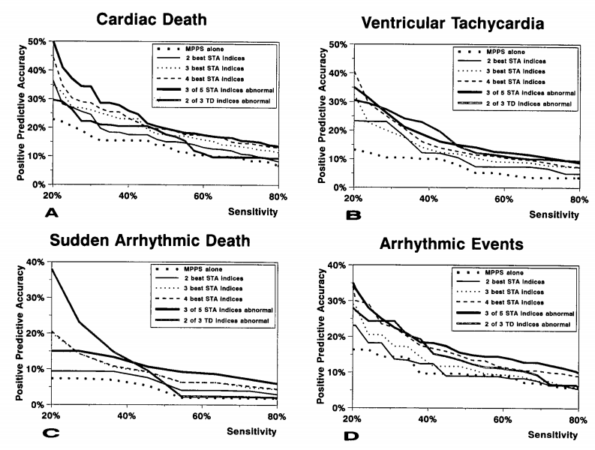

**Figure 1.1, 1.2**: PPC of individual indices on different types of cardiovascular disorder and criteria

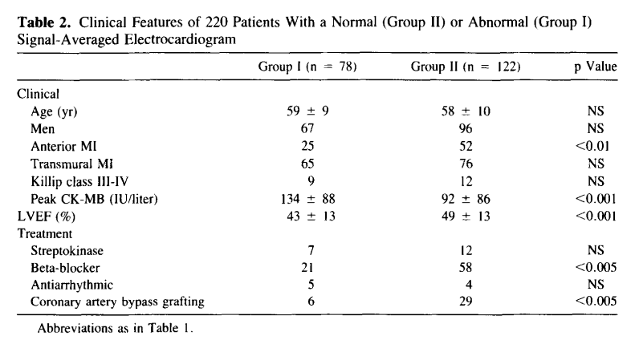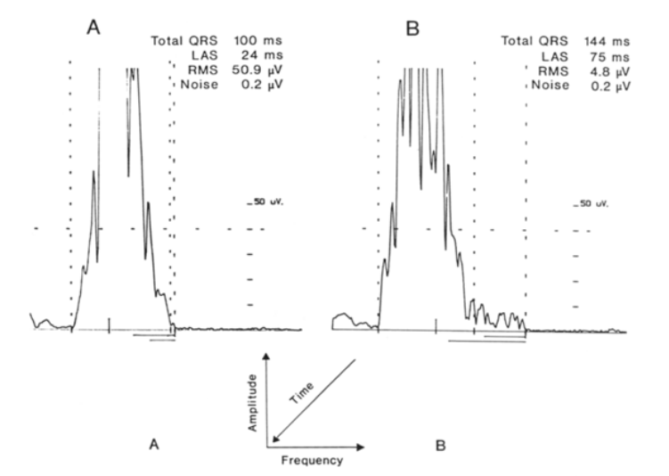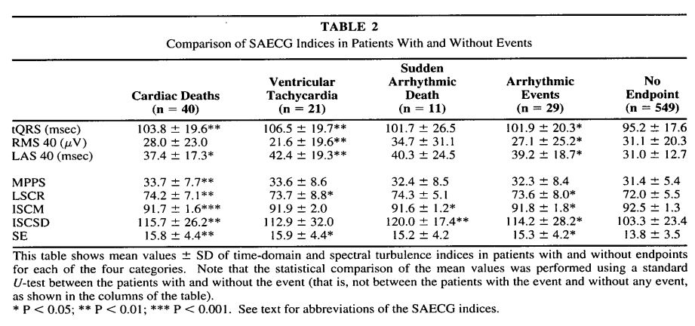

**Figure 3.1** SAECG of sinus rhythm and ventricular tachycardia

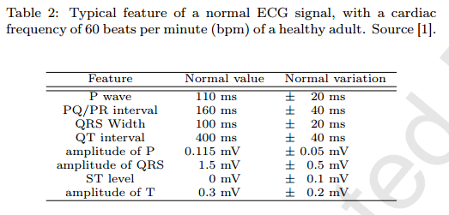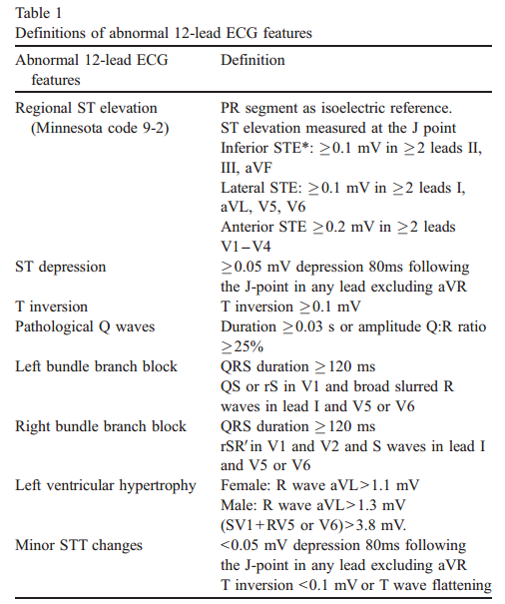

Figure 8: popular features extracted from RR intervals

Figure 6: features extracted from ST intervals

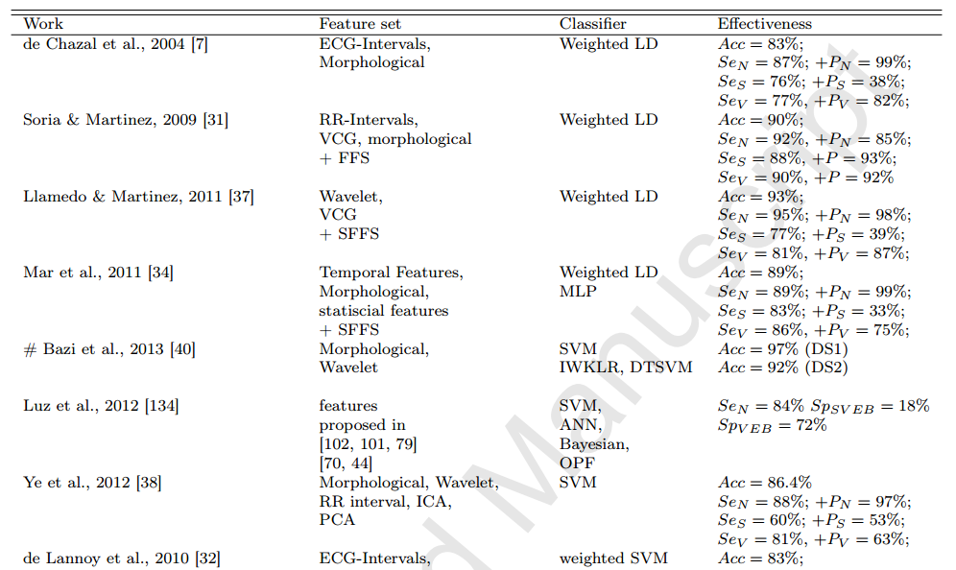

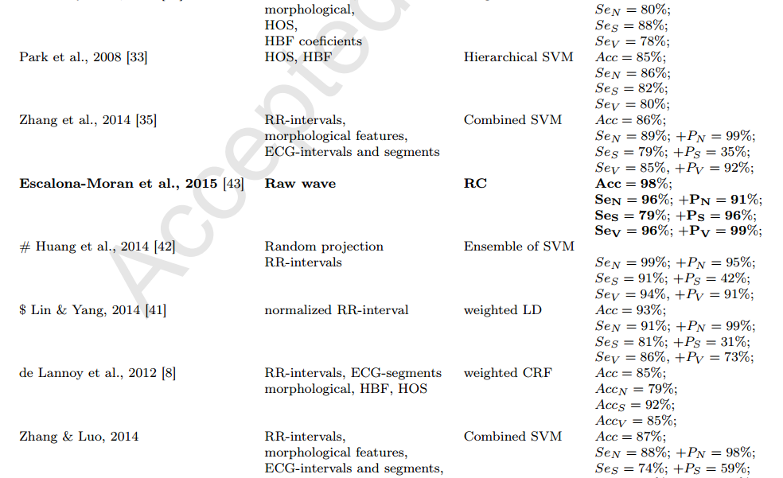

Figure 9: summary of the article [9], different classification algorithms using different set of features create different results. The state-of-the-arc learning algorithm is the RC which does not use any features at all.